RATIONALIZATION
Pearson Edexcel - Thursday 7 June 2018 - Paper 2 (Calculator) Higher Tier
1.
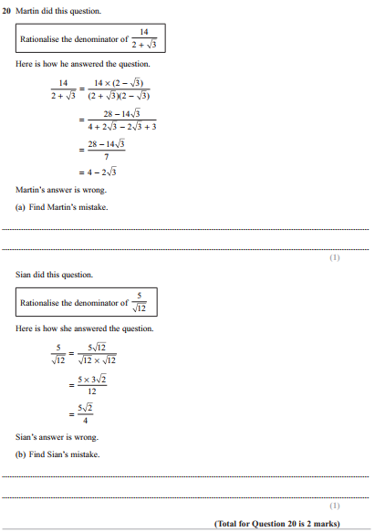

Pearson Edexcel - Thursday 2 November 2017 - Paper 1 (Non-Calculator) Higher Tier
2.
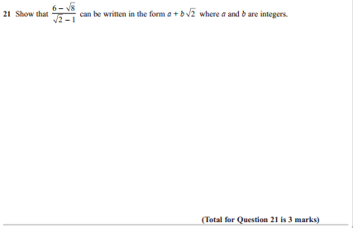
Pearson Edexcel - Specimen Papers Set 1 - Paper 1 (Non-Calculator) Higher Tier
3.
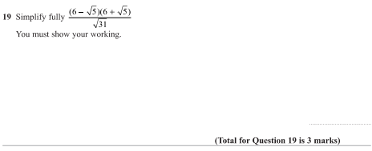
Pearson Edexcel - Wednesday 4 November 2015 - Paper 1 (Non-Calculator) Higher Tier
4.
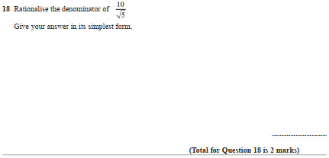
Pearson Edexcel - Monday 9 June 2014 - Paper 1 (Non-Calculator) Higher Tier
5.
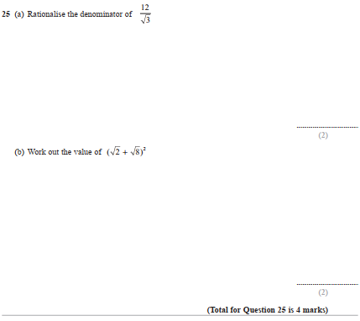
Pearson Edexcel - Tuesday 6 November 2012 - Paper 1 (Non-Calculator) Higher Tier
6.
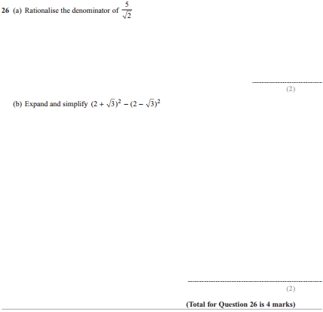
7.

